HISTORICAL HEADS OF STATE

JUAN SEBASTIAN PEÑA AND SIMON URIBE

UNITED NATIONS BACKGROUND

ASPAEN MANIZALES
VILLAMARÍA, CALDAS
AGOSTO 2024
INDEX
1. Letter from the chair 3
1. Introduction to the commission 4
1.1. Procedure 4
1.2. Purpose 4
2. Delegations 5
2.1. Topic A 5
2.2. Topic B 5
3. Requirements 5
4. Topic Information 6
4.1. Topic A: World War I (Historical) 6
4.1.1. Blocs 6
4.1.2. Key terms 6
4.1.3. Essential questions 6
4.1.4. Bibliography 6
4.2. Topic B: Italian Risorgimento (Historical) 7
4.2.1. Blocs 7
4.2.2. Key terms 7
4.2.3. Essential questions 7
4.2.4. Bibliography 8

Letter from the chair
Dear delegates,
We extend a warm and heartfelt welcome to you from the esteemed board of directors of Aspaen Manizales, and the chair of the Historical Heads of State committee. It is a great honor for us to serve as the chair of the HHS committee, we are confident that this experience will be one that we can all cherish, enjoy, and remember. We are committed to creating a commission that is not only friendly and supportive but also one where thorough preparation and continuous learning are highly encouraged and actively practiced.
As presidents, we hold high expectations for you, the delegates, to give your absolute best effort. We wish you the utmost success as you advocate for the interests of your states and countries, working diligently to find effective solutions to the complex issues presented within the commission.
We assure you that we will facilitate a moderated and smoothly flowing caucus, ensuring that each delegate is provided with ample opportunities to demonstrate their abilities and strive to become the best delegate possible. Please do not hesitate to reach out to us with any questions, doubts, or suggestions, as we are here to support you throughout this journey.
Sincerely,
Historical Heads of State chair.

Juan Sebastián Peña Sánchez
(+57) 322 8353578
jsps1803@gmail.com
Simon Uribe
(+57) 311 301987
simon.uribe@aspaen.edu.co

Introduction to the commission

Procedure
In this committee, you will not represent a country, but a determinant head of state. Thus, in order to have an outstanding performance, it's critical that you represent your character —comprehending their objectives, motives, and beliefs—. Following these recommendations will lead to a great committee.
The committee will revolve around directives, each bloc has to send a directive every hour of debate, each hour will represent one year in the historical timeline, after 30 minutes of the directive being sent, the chair will announce the results of the previous directive of each bloc. We expect comprehensive and realistic directives —the chair will specify the military power of each nation to each delegate—, directives will be delivered via google docs, so each bloc can communicate while the caucus is going. A directive example will be provided.

Purpose
The committee's main goal is to be a place for debate and respectful argument, where the stated problems can be solved by the commission. We look for a fluid debate, absolute focus on the subject and a serious attitude toward the discussion without sacrificing feeling. We are anxious to get to know your argumentative, oratorical and synthesis skills.
We anticipate a welcoming and exciting atmosphere, we will not put up with any rudeness directed at a committee member. But feel free to criticize any delegation without regret or fear, making sure to always attack with arguments and avoid taking it personally.

Delegations

Topic A
Emperor Franz Joseph I | King Albert I | President Raymond Poincaré | King Victor Emmanuel III | King George V
Kaiser Wilhelm II | Sultan Mehmed V | Tsar Nicholas II | President Woodrow Wilson | King Alfonso XIII

Topic B

Requirements
- Position paper
- Black and white paper (Optional)
- One minute and thirty seconds opening speech
- Be respectful
- Be correctly prepared for the committee
- Parliamentary language (First person allowed)
- Dress code
- Eight to nine MUNs of experience minimum

Topic Information

Topic A: The Great War (Historical)
After a Bosnian Serb named Gavrilo Princip assassinated Archduke Franz Ferdinand of the Austro-Hungarian Empire, in the city Sarajevo—Nowadays Bosnia and Herzergovine capital—, on July 28, 1914. The assassin was part of nationalist group aiming to free Bosnia from Austro Hungarian control and merge it with Serbia leading to a series of diplomatic conflicts, among major European powers connected by intricate alliances and military agreements which turned into “The Great War”.
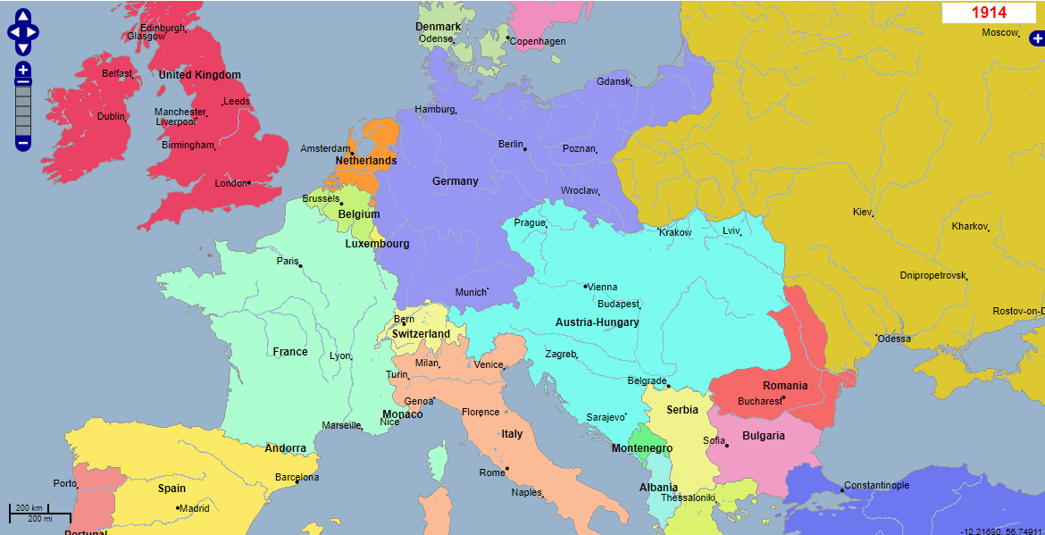
Following the 1914 assassination event, Austria-Hungary joined forces with Germany, and on July 23, of that year, sent an ultimatum to Serbia. The requirements were very strict; they demanded that Austrian and Hungarian officials be included in trials of the persons responsible for the assassination that occurred in Serbia.
Serbia attempted to respond in a conciliatory manner, but it was difficult for it to accept these demands without endangering its independence when it faced support from Russia. Despite this, Austria-Hungary, supported by Germany, rejected Serbia's response and declared war on Serbia on July 28, 1914.
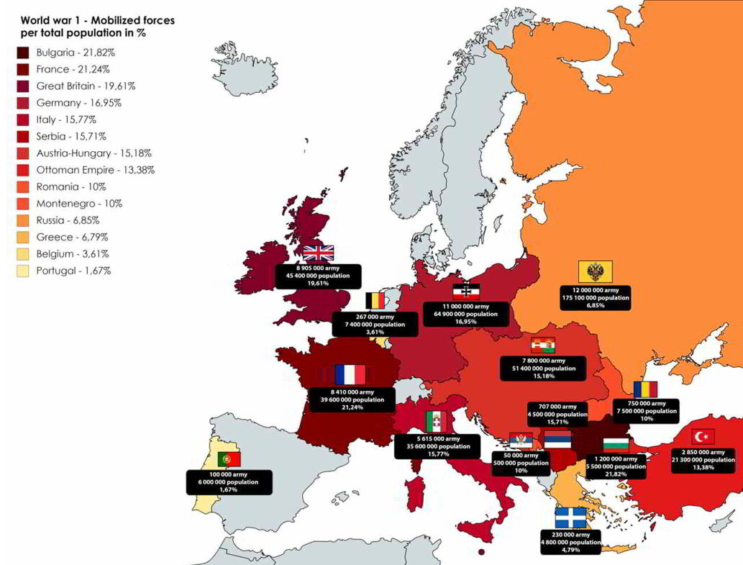
The initiation of hostilities signified the starting point of the breakdown of the relations in Europe at that time period in history. In 1914 on July 30th specifically Russia, who had positioned itself as the protector of Slavic nations, took steps to mobilize its forces to assist its ally Serbia.
During this era, mobilization was not a routine procedure; it held significant weight and often led to war declarations. Germany had concerns about being surrounded by Russia in the east and France in the west which made them perceive mobilization as a direct and imminent danger. On the day of August in 1914 Germany announced its declaration of war against Russia. The alliances established in the period before the war were now set in motion bringing Europe to the threshold of a full scale conflict.
Germany’s war plan, known as the Schlieffen Plan, called for a rapid strike against France, Germany’s western neighbor and a key ally of Russia. The plan involved invading Belgium, a neutral country, in order to bypass France’s heavily fortified border. On August 4, 1914, Germany invaded Belgium, violating its neutrality. This action outraged Britain, which was bound by treaty to defend Belgium’s sovereignty. On the same day, Britain declared war on Germany. With Britain’s entry into the conflict, the war had now become a truly global one, as the British Empire would draw upon resources and manpower from its colonies around the world.
A large portion of Europe had begun preparing for war by early August 1914. The Central Powers were made up of Germany, Austria-Hungary, and the Ottoman Empire (which would join later in the year), while the Allied Powers were made up of France, Russia, and Britain. As the conflict grew, colonial subjects from Africa, Asia, and the Caribbean were dragged into it as either workers or soldiers, while other countries like Japan and Italy joined the Allies. All of Europe's main countries were now involved in the conflict, which had begun as a regional conflict between Serbia and Austria-Hungary and had extended to the Eastern Front in Russia and other places as well as the Western Front in France and Belgium.
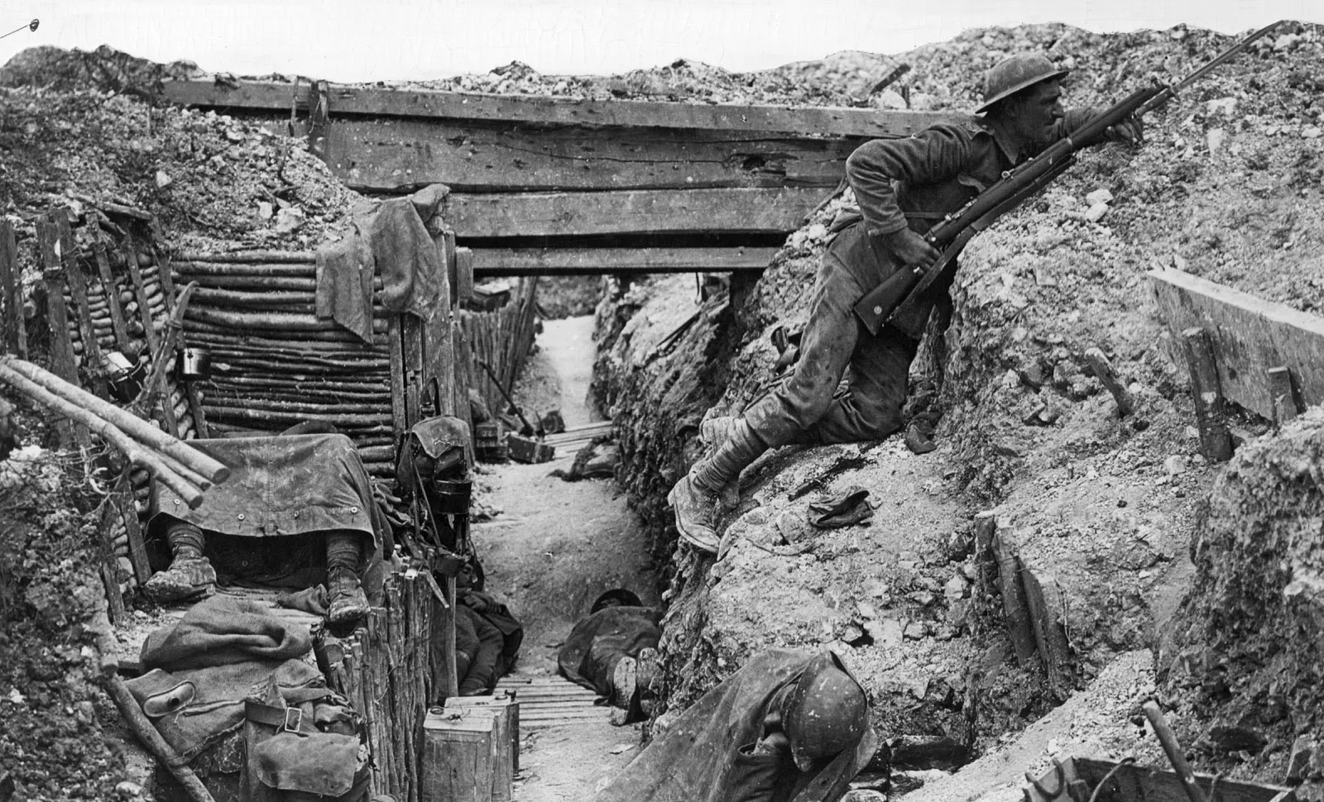
The war's early phases were characterized by decisive engagements. Germany's assault of Belgium and northern France in the west started out as planned. By early September 1914, German forces had progressed rapidly and were within striking distance of Paris.
However, the use of primitive aircraft used for reconnaissance and, above all, a German message sent by mistake without encoding that is captured by an antenna placed on top of the Eiffel Tower, let the Allies know that the German troops were exhausted which reached out to a crucial turning point, the Battle of the Marne, where British and French troops improvised a counter attack so much so that the governor of Paris gave the order that all taxis in the city directly transport reservist soldiers to the front, which took place between September 5 and September 12, 1914.
The German assault was stopped by French and British forces, and the Schlieffen Plan—which was intended to prevent a drawn-out conflict on two fronts—failed, causing at least half a million casualties in each of the sides.
The conflict was more fluid in the Eastern Front, where massive engagements were fought over enormous swaths of territory. At first, Russian forces threatened Germany's eastern boundaries by advancing into East Prussia. But at the Battle of Tannenberg, which took place in late August 1914, German forces led by Generals Paul von Hindenburg and Erich Ludendorff decisively defeated the Russian army, causing significant casualties along the way. The Easter Front continued to be a scene of intense combat despite this win, with significant casualties on both sides.
As the war produced on, expectations for an immediate and resounding victory fell apart. With the aim of wearing down the opponent by prolonged military operations, and economic pressure, the battle evolved into an attrition war. The battle became increasingly deadlier with the arrival of new technologies like machine guns, poison gas, tanks, and airplanes.
Significant political and societal repercussions also resulted from the war. Discontent among the inhabitants of the warring nations increased as the battle became more intense. The stresses of the war also played a role in the 1917 Russian Revolution, which brought down the Romanov monarchy and gave rise to the Bolsheviks, who would eventually pull Russia out of the war with the signing of the Brest-Litovsk Treaty in 1918. The war caused social unrest, inflation, and food shortages in other nations, such as Germany and Austria-Hungary, which threatened the stability of their governments and opened the door for revolutionary movements.
The Central Powers had reached the end of their military and economic endurance by 1918. The United States' entry into the war in April 1917, which brought in additional troops, cash, and supplies, swung the scales in the Allies' favor. A succession of successful Allied offensives on the Western Front during the last months of the war forced the Central Powers to negotiate an armistice as German forces were driven back. The guns stopped on November 11, 1918, at 11 a.m., marking the end of The Great War.
The war's aftermath would drastically alter the course of history. The 1919 Treaty of Versailles redrew the borders of Europe, placed severe sanctions on Germany, and set the stage for further hostilities. After the Ottoman and Austro-Hungarian empires fell, new countries arose in their former lands. The global order was also profoundly impacted by World War I, which paved the way for the emergence of fascism, communism, and ultimately World War II. With an estimated 16 million dead and millions more injured, both physically and psychologically, the human cost of the conflict was tremendous.

The Trench War
We can say that Trench Warfare was the complete dehumanization of warfare. Both sides set up their trench systems supported by thousands of artillery pieces that bombarded enemy positions day and night. In between both trench systems was no man's land. And why were there so many corpses in that area? Because the tactics were to send men to the slaughter. Send wave after wave of men into the enemy trench. Soldiers who had to dodge the barbed wire were easy targets for enemy machine guns. Hundreds of thousands of soldiers died this way, in senseless suicide attacks.
Moreover, the living conditions in the trenches were absolutely inhuman. Imagine living in holes full of mud and puddles, with rats running rampant, with lice, diseases, the rotten smell of decomposing bodies that could be your trench mate. And worst of all, being for months without sleep because of the noise of the bombardments and the stress of knowing that at any moment a shell could kill you. Many soldiers went crazy and a disease known as war fatigue appeared, caused by the sustained stress. At first, those suffering from war fatigue were shot because it was believed that they were soldiers acting to get out of fighting, but eventually it was seen that it was a real mental illness. Other diseases also appeared, such as trench foot, an infection caused by having wet feet at low temperatures for a long time, which led to amputation.
In the end, each side developed its own tricks to better manage trench warfare, although the Allies adapted better. Even so, the casualties resulting from the hard life in the trenches were uncountable.

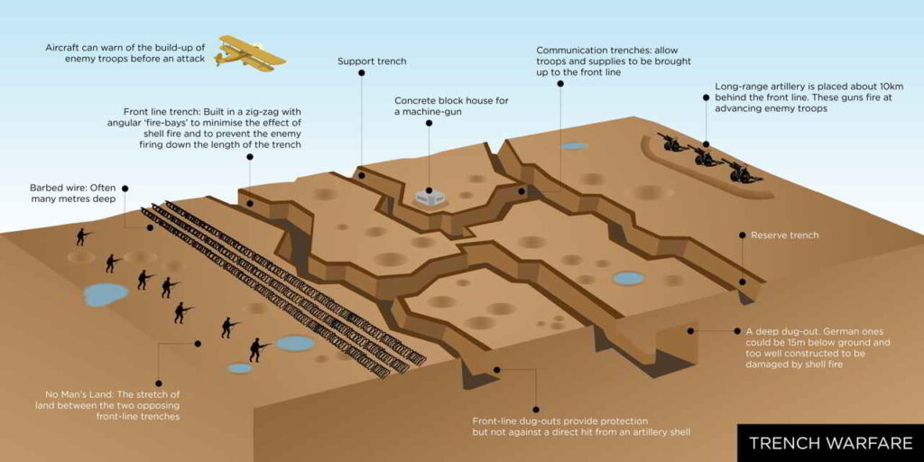
Ottoman entry to the great war.
With the stabilization of the European fronts, the war reached more places. Australia seized German possessions in New Guinea. In Africa the Allies also began to take German colonies. The war of attrition that had begun was complicated for Germany, which was also suffering a maritime blockade by the United Kingdom in the North Sea.But beware that things could change if Germany looked for more allies. And so it was, Japan joined Germany, seeing that the German territories in the Pacific were a boon, and on the other hand, in 1915 the Ottoman Empire joined Germany.
The Ottoman Empire was not for many parties since it had just been defeated in its war against the Balkans, the one that caused the independence of a lot of Eastern European countries, everything that is to find a small opportunity to enlarge their empire is good for them.

Italy switches sides
By taking advantage of Italy's rivalry with France, providing diplomatic and military backing, and ensuring that the alliance was defensive in nature, Germany first persuaded Italy to join the Triple Alliance in 1882. Italy was persuaded by German Chancellor Otto von Bismarck, who promised to upgrade the armed forces and presented the alliance as a way to shield Italy from French aggression. Germany told Italy that it would not have to face Austria despite Italy's territorial conflicts with Austria-Hungary.
There was some tension between the Italians and the Austro-Hungarians and the Allies seized the opportunity by offering the Austro-Hungarian Empire the territories of Tyrol and Trieste as war goals against Austro-Hungary, the Italians accepted, switched sides and opened a new front against the Austro-Hungarian Empire.

Blocs
Block A | Neutrals | Block B
Emperor Franz Joseph I | King Albert I | President Raymond Poincaré
Kaiser Wilhelm II | Sultan Mehmed V | Tsar Nicholas II
King Victor Emmanuel III | President Woodrow Wilson | King George V
 | King Alfonso XIII

Essential questions
- How was my country involved in the Great War?
- Which side would be more beneficial for my country to take?
- What is the military power of my country, how could I take advantage of it?

Key terms
- Armistice: An agreement between warring parties to stop fighting temporarily or permanently. The armistice signed on November 11, 1918, marked the end of hostilities on the Western Front and led to the formal end of World War I.
- War of Attrition: A strategy where each side attempts to wear down the other by inflicting continuous losses. World War I saw extensive use of this strategy, particularly on the Western Front, leading to high casualties and prolonged conflict.
- The Treaty of Versailles: The peace treaty that officially ended World War I. Signed in 1919, it imposed heavy reparations and territorial losses on Germany, contributing to political and economic instability in the interwar years.

Bibliography
- https://www.britannica.com/event/World-War-I
- https://memoriasdepez.com/primera-guerra-mundial/
- https://www.bbc.co.uk/bitesize/articles/znhhrj6

Topic B: The Italian Risorgimento (Historical)
The Italian Risorgimento was the process by which the nations that made part of what we know today as Italy took part in the unification of the whole Italic peninsula.
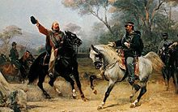
17th march 1861 this new country was born in Europe. Unified for the first time since the fall of the West Roman Empire after almost 14 centuries under the control of the Saboya’s monarchy. This unification known as the Italian Risorgimento was the result of a severe amount of wars, political decisions, betrayals, luck, and many other unique conditions.
After too many centuries of Italy being divided and controlled by different enormous and important empires, and with the spirit of revolution spread by the French Revolution and Napoleon Bonaparte with the intentions of the unification of the whole Europe, these intentions of unification and liberty took the whole opposite sense meant by France, by causing a revolutionary and independence intention in the city-states that conformed the Italic Boot.
The Italian Risorgimento was an ideological and literary movement with the purpose of increasing and creating a feeling of excitement about the national consciousness amongst the Italian people.
The Italian Risorgimento was the result of a process that lasted more than 60 years.
Formally, it all started in 1815, during the Congress of Vienna, where the powers that had defeated Napoleon-Austria, Russia, Prussia and Great Britain drew a new geopolitical map of Europe, with the objective of renegotiating the influence and balance of all powers, trying to avoid revolutionary revolts.

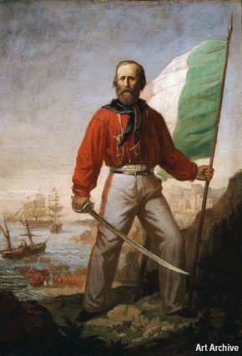
On January 1st, 1820, a revolt broke out in Cadiz, Spain, demanding the change of the spanish constitution of 1812. Ferdinand VII was forced to do so in this same year, which caused the spread of revolutionary acts along all Europe, becoming a model for Italy's growing nationalistic feeling. Thanks to this, members of the liberal unification movement around the peninsula started demanding a constitution too, which was granted in two different kingdoms, the Kingdom of Sardinia and the Kingdom of Two Sicilies. Even so, the monarchies asked for military help from Austria for repressing the nationalistic sentiment, causing the revolutionary armies to be defeated and the monarchies’ power fully restored in 1821.
Around 10 years later, 1831, a second wave of revolutionary sentiments occurred, and began to spread from Modena to Perugia, thanks to the support of the liberal aristocracy, the bourgeois class and some popular consensus. There were intentions of creating a governmental constitution, but, once again, these revolts were violently suppressed by the Austrian army, restoring the reign of the monarchs in those states.
During the following two years, with a waiting Italy, and the monarchy's absolute power being at the top, the revolt spirit was still in the hearts of many Italians. And, in 1833, the political society established by Giuseppe Mazzini, “La Giovine Italia (Young Italy)” organized the first revolts that aimed for creating a unified nation, by encouraging a popular insurrection on the reactionary states. Unfortunately for the Young Italy, this movement was suppressed, causing the arrestment or exiling of many patriots, between them Giuseppe Garibaldi, who was exiled in South America, where he fought for Uruguayan independence.
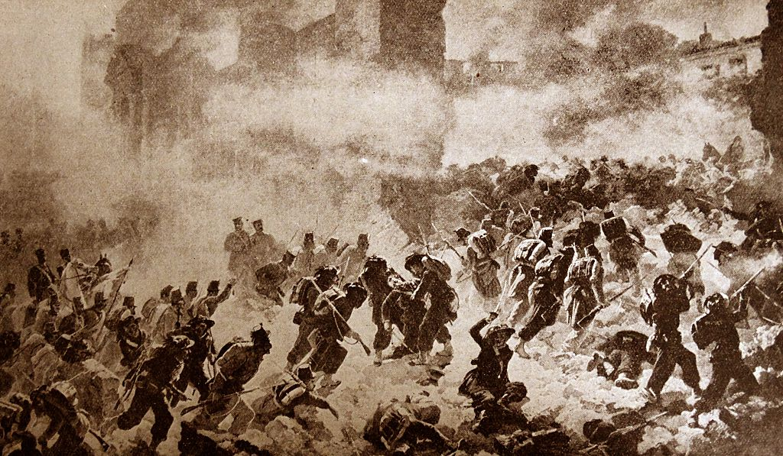
During the next 10 years, the intentions of revolt, and the spirit of a unified Italy were preparing for a new outbreak, once again under the organization of Mazzini a new wave of nationalistic revolts came, but again suppressed and with the result of many revolutionaries arrested or killed. Meanwhile, in the same year of these revolts, 1843, Vincenzo Gioberti proposed a new way to reach the unification of Italy, throughout one Italy under the rule of the pontiff.
Either way, the revolutionary efforts and attempts continued, this time, a revolt organized by the Bandiera brothers (Attilio and Emilio Bandiera), with the intention of the creation of an independent, united and democratic Italian republic with Rome as its capital. However there was not enough support and they were violently suppressed.
After many harsh defeats, a new light of faith came for the revolutionary Italy, this time by the election of Pope Pius IX in 1846 coming with hope for the revolutionaries, and also giving an important boost to Gioberti’s theory of the ruling of a unified Italy by the pontiff, attracting many new supporters and leaving aside the intents of revolution by Mazzini, because of the very low efficiency and the great amount of deaths caused.
An economic crisis hit the Italic boot, causing a huge disgruntling around the citizens, increasing the costs of many things specially food, influencing the reforms that were applied in the Papal States, Tuscany’s Grand Duchy and the Kingdom of Sardinia, and still reaching the suppression of the revolutionary attempts.
An important wave of revolutionary spirit came by the time of the new European political order of the Congress of Vienna which crossed the entire continent. The first revolts occurred in Paris, the nationalistic sentiment traveled to Berlin and Vienna, where Prince Metternich fell from power, leading to a new constitution, and finally, reaching the duchies in Italy, weakening Austria’s reign and domination in the peninsula, around 1848.
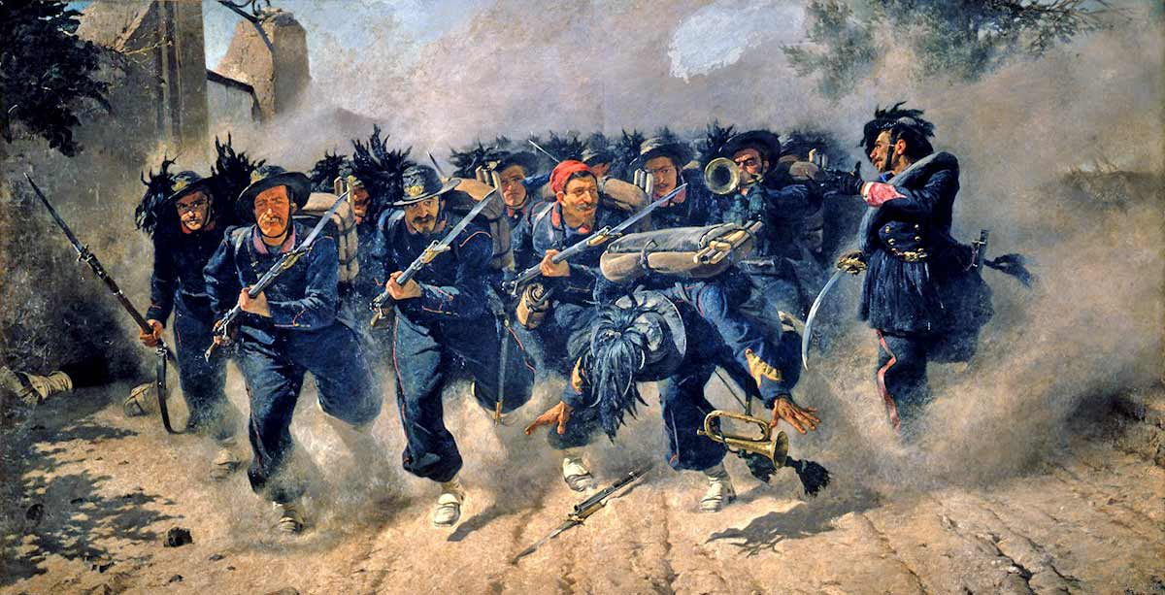
This caused a huge avalanche in the revolutionary spirit in Italy, causing the reactionary armies to defeat the constitutional and republican governments established in the last 20 years. Finally, after years of revolutionary effort, the Austrian armies were defeated in Lombardy-Venetia, Parma, Modena and Bologna, the Marche region, Romagna and Tuscany. The French armies went back to Rome returning to the Pope, causing a sense of bewilderment in the population of France and Italy.
Lately, the Kingdom of Sardinia approved the Saccardi laws, damaging the relationship with the catholic church. While Pope Pius IX returns back to Rome, Garibaldi goes to New York City and Mazzini to London.
In 1855, allied with France and Great Britain, the Kingdom of Sardinia entered the war with Russia, sending a military expedition to fight in the Crimean War, and with this, ensuring the support of France and Great Britain to Austria in the peninsula. Meanwhile, the cholera reached epidemic levels and caused a huge amount of deaths.
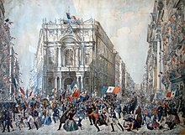
The military expedition to Pisacane was a complete failure, and with the insurrections led by Mazzini his leadership of the democratic movement was finished. The Italian National Society was established, seeking to unite democrats and moderates with the same aim of freeing Italy from the monarchies power, in this case, specially the Savoy monarchy. The Kingdom of Sardinia aimed to isolate Austria in an international stage and increased military presence in the Lombardy-Venetian border.
In 1858, there was a failed attempt of assassination to Napoleon III, but that didn’t change the relationship between the Kingdom of Sardinia and France, actually, it caused the French emperor to help the Italian Nationalist forces with military help, an action that was asked a time before by Count Cavour, the prime minister of Piedmont, turning into an agreement between Cavour and Napoleon III known as “Patto di Plombiéres (Pact of Plombiéres)” in which they both join a war against Austria. With this fact, Mazzini in exile in London dissociated himself from this Franco-Piedmont plan.
A year later, Napoleon III and Victor Emmanuel II formed a military alliance against Austria, and the second war for independence in Italy broke out. This caused the freedom of Lombardy from the Austrian Empire, bringing Tuscany, Parma, Modena, Romagna, Marche, Umbria and the provisional governments to ask for the annexation to the Kingdom of Sardinia. Meanwhile, Napoleon III signed an armistice in Villafranca with Franz Joseph, the Austrian emperor, because of the constant fear of a military attack by Prussia and the surprising revolutionary activities in central Italy.
In 1860, Garibaldi organized the expedition of the 1,000 men (The Mille) with the objective of liberating the Kingdom of Two Sicilies and the Papal States, making this expedition a complete success, and just after three months “The Mille” defeated the Bourbon army. No matter the success, Victor Emmanuel II met “The Mille” in Teano, preventing them from moving to Rome, which was under the protection of the French army. Garibaldi gives the Bourbon government power to the king, and it is annexed in the Kingdom of Sardinia, and finally, except for Rome and Venetia, the Italian peninsula is united as a republic.
Finally, in 1861, after years of revolutionary intentions, the Italian State was born. Victor Emmanuel II was proclaimed king of Italy, and he assembled the deputies of the first Italian Parliament in Turin on March 17, 1861, and only 10 days later, Rome was declared capital of Italy, even though it was not part of the new nation yet.
In 1862, Garibaldi organized an expedition to conquer Rome, but he was stopped by the Italian army in the Calabrian mountains of Aspromonte and he got injured in the attack. Meanwhile the Italian unification proceeded with administrative reforms and the adoption of a common monetary system, although in the south in 1863, it would start a civil war that would last 10 years against the brigandage.
In 1865, the French troops gradually retreated from the Papal States, as the Italian government transferred their capital city from Turin to Florence. Just a year later the third war of independence broke out when the Austrian-Prussian war gave Italy an opportunity of becoming allies with Prussia in an attempt to liberate Venetia. Prussia wins the war and Venetia was annexed to Italy.
Garibaldi still had the idea of making Rome the capital of the now unified Italy, and he started an expedition, but he was stopped by the French men in Mentana, at the gates of Rome. In 1870 France declared war against Prussia, causing the last French troops to leave the Papal States, a situation from which Italy took advantage sending a military expedition to fight the Papal States, which resulted in France being defeated by Prussia and Rome falling being occupied by the artillery.
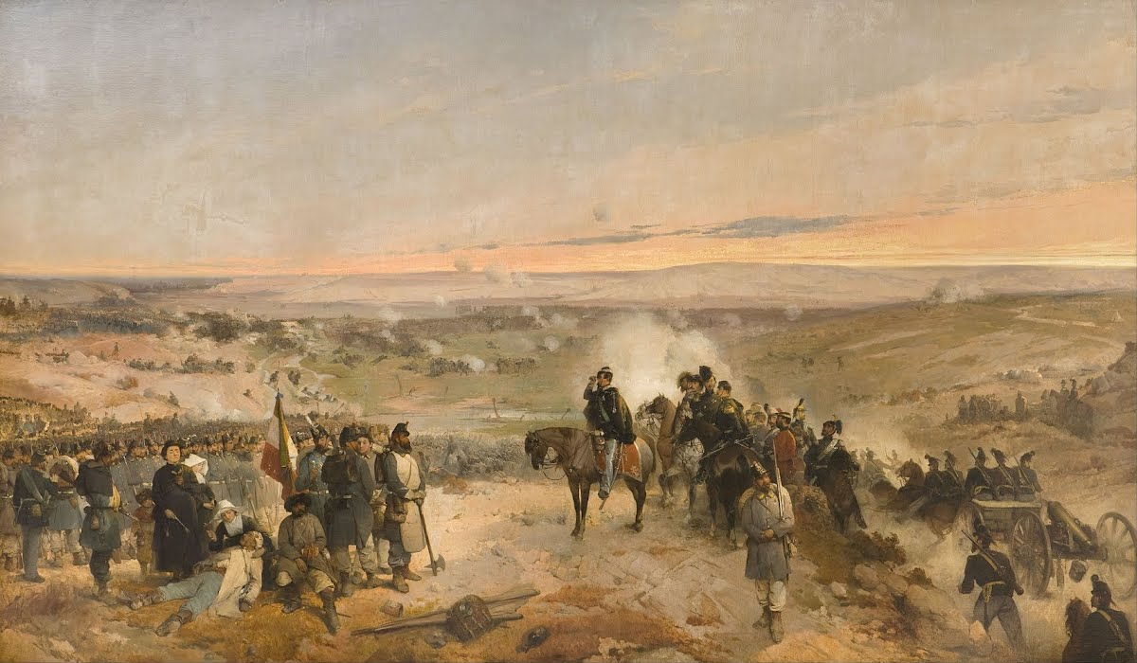
In 1871, the Italian Risorgimento came to an end, when Rome was made capital of the Kingdom of Italy, and with the approval of the pope as the new spiritual leader by the parliament.

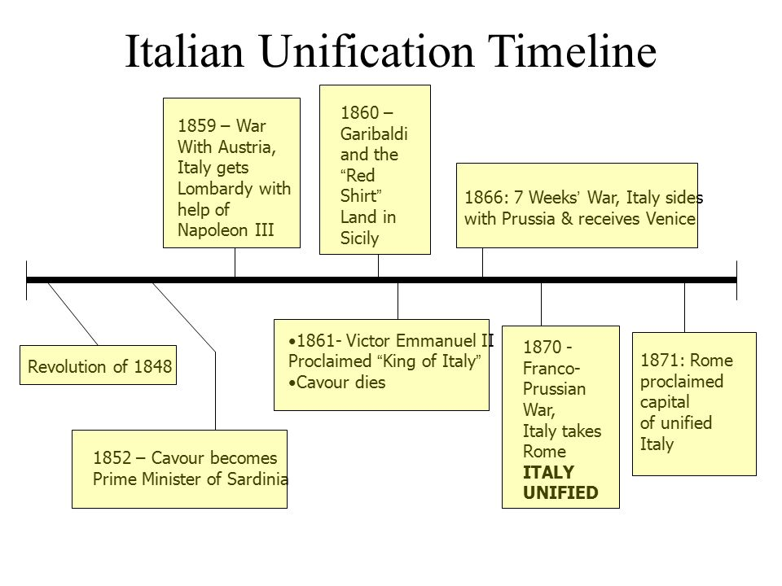
Italian Risorgimento Timeline

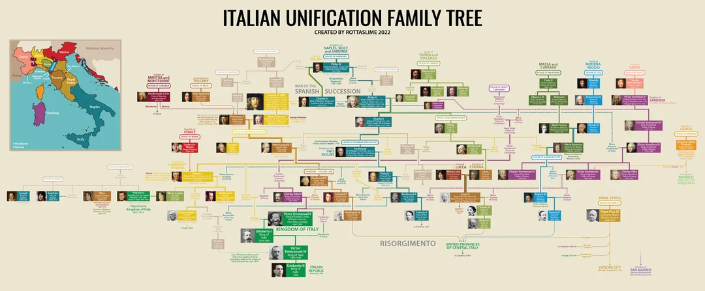

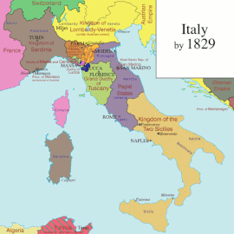
Historical Context of the Italian Risorgimento
The Italian Risorgimento was a 19th century movement that was provoked by an important historical context that was developed a century before.
The main impetus of the Italian Risorgimento was the reforms introduced by French people, by the time in which France dominated Italy during the period of the French Revolutionary and Napoleonic wars (1796 - 1815). During this period of time, some of the Italian regions and states were briefly consolidated, first as republics and afterwards as satellite states of the French empire; and, thanks to these important changes in the Italian peninsula, it was allowed to the Italian middle class to grow and allowed to participate in the government.
After Napoleon’s defeat in 1815, these Italian states were restored to their original former rulers, but the revolutionary and nationalist spirit stayed in many Italians.
Subsequently, these states took a conservative character under the domination of Austria, causing the creation of some secret societies or revolutionary groups such as the “Carbonari” in the 1820s and 30s or the first avowedly republican and national group “Young Italy”, founded by Giuseppe Mazzini in 1831, a very important character in the Risorgimento.
These nationalist groups, which represented the democratic aspects of the Risorgimento, hoped to educate the Italian people to sense their nationhood and to encourage the masses to rise against the existing reactionary regimes.

Blocs
Bloc A | Neutrals | Bloc B
Ferdinand I of Austria (Austria) | Napoleon III (France) | Victor Emmanuel II (Sardinia-Piedmont)
Prince Mustapha Fazil Pasha (Ottoman Empire) | Charles III (Parma) | Francesco II of Bourbon (Two Sicilies)
Franz Conrad von Hötzendorf (Austria) | Carlo Ludovico Di Borbone (Lucca) | Pope Pius IX (Papal State)
 | Duke Francis IV of Habsburg-Este (Módena)

Key terms

Italian Risorgimento: The process of Italian unification was the result of nearly 60 years of events, daring action and revolutionary ideas.
- Term 2: Italian Peninsula: The Italian Peninsula, known variously as Apennine or Italic Peninsula, is one of the three largest peninsulas in southern Europe. It is an elongated and part of continental Italy that extends from the Alps into the central Mediterranean Sea. It stretches from the Po River on the north towards the sea.
- Term 3: Brigandage: Plundering by brigands.
- Term 4: Brigand: Someone who attacks people and robs them, especially in mountains or forests.

Essential questions
- What is the role of your delegation in the Italian Risorgimento?
- What is the position of my character regarding the intentions of each kingdom or country?
- Does my character have military influence?
- What are the roles of each Kingdom and country in the Italian Risorgimento.

Bibliography
- https://www.collinsdictionary.com/es/diccionario/ingles/brigand
- https://www.theflorentine.net/2011/03/10/the-italian-risorgimento-a-timeline/
- https://www.wordreference.com/es/en/translation.asp?spen=respecto
- https://www.britannica.com/event/Risorgimento

